Comparative Analysis Of Seasonal ARIMA (SARIMA) And XGBoost Models For Retail Sales Forecasting Using The Store Sales Dataset
Veronica Febriani Putri ^{1*}, Nadiarista Yustiaputri², Dhea Ary Shofyan³
¹Department of Statistics, Faculty of Science and Data Analytics, Institut Teknologi Sepuluh Nopember, Surabaya 60111, East Java, Indonesia
²Department of Statistics, Faculty of Science and Data Analytics, Institut Teknologi Sepuluh Nopember, Surabaya 60111, East Java, Indonesia
³Department of Statistics, Faculty of Science and Data Analytics, Institut Teknologi Sepuluh Nopember, Surabaya 60111, East Java, Indonesia
E-mail Correspondence Author: 5003231121@student.its.ac.id¹

Abstract
Retail sales forecasting is essential for effective inventory management, supply chain optimization, and strategic planning, especially in economies sensitive to external factors such as oil prices and holidays. This study presents a comparative analysis of Seasonal Autoregressive Integrated Moving Average (SARIMA) and XGBoost models for predicting daily sales of the GROCERY I category at Store 1 using the Kaggle Store Sales dataset (2013–2017). Preprocessing involved merging auxiliary datasets (stores, oil, holidays), handling missing values via forward fill and mean imputation, feature engineering (day-of-week, holiday indicator, oil price), and stationarity verification using the Augmented Dickey-Fuller test. SARIMA parameters were optimized with auto-ARIMA incorporating exogenous variables, resulting in the model (3,1,0)(1,1,1)[7]. XGBoost utilized lag features (7 and 14 days), rolling statistics, and exogenous variables. Performance evaluation on a fair overlapping test period, using MAE, RMSE, and MAPE metrics, showed XGBoost outperforming SARIMA (MAE = 178.32, RMSE = 232.07, MAPE = 10.43% vs. MAE = 196.77, RMSE = 246.74, MAPE = 11.73%). Feature importance analysis revealed day-of-week and holiday effects as dominant predictors. These findings indicate XGBoost's superiority in capturing non-linear interactions in limited retail time series data, offering practical implications for demand forecasting in volatile markets.

Keywords: Time Series Forecasting, SARIMA, XGBoost, Retail Sales, Store Sales Dataset

: https://doi.org/10.30598/parameterv4i1pp55-62
This article is an open access article distributed under the terms and conditions of the Creative Commons Attribution-ShareAlike 4.0 International License.

- INTRODUCTION
Accurate sales forecasting in the retail sector is essential for efficient inventory control, reducing waste, and maximizing profits. In Ecuador, where the economy is heavily dependent on oil exports, retail sales are influenced by fluctuating oil prices, national holidays, and promotional activities. The Store Sales - Time Series Forecasting dataset from Kaggle provides comprehensive daily sales data across 54 stores and 33 product families from 2013 to 2017, offering an ideal platform for testing forecasting models.
This study focuses on Store 1 (classified as GROCERY I in Ambato, Ecuador) to compare two prominent time series models: Seasonal ARIMA (SARIMA), a statistical approach suited for data with trends and seasonality and XGBoost, a gradient boosting machine learning method capable of handling non-linear relationships and complex interactions through tree-based ensembles. The problem addressed is the selection of an optimal model for short-term sales prediction amid external variables. Objectives include data preprocessing, model implementation and tuning, performance evaluation via error metrics and cross-validation, and identifying the superior model.
The novelty lies in integrating exogenous factors (promotions, oil prices, holidays, day-of-week) into both models for an Ecuador-specific retail context, where prior studies often overlook such influences. This analysis contributes to the literature by demonstrating model efficacy on real-world data, aiding retailers in demand planning.

- THE COMPREHENSIVE THEORETICAL BASIS
Time series forecasting is a fundamental technique for predicting future values based on historical data collected at regular intervals, such as daily retail sales. It is crucial in retail for demand planning, inventory management, and supply chain optimization. Key elements include trends, seasonality, and cycles, where seasonality refers to recurring patterns like weekly or holiday-driven fluctuations, and exogenous variables (e.g., oil prices, holidays) can introduce non-linearities. In volatile markets like Ecuador's oil-dependent economy, incorporating these factors is essential for accurate predictions.
The Seasonal Autoregressive Integrated Moving Average (SARIMA) model extends ARIMA to handle seasonality, making it suitable for data with periodic patterns. SARIMA is parameterized as (p,d,q)(P,D,Q)[m], where p,q are non-seasonal orders, d is differencing, P,Q,D are seasonal orders, and m is the seasonal period (e.g., 7 for weekly data). It excels in linear, stationary time series and can include exogenous variables (SARIMAX) for improved performance. Studies have shown SARIMA's effectiveness in retail forecasting with strong seasonal components.
XGBoost, an optimized gradient boosting framework, is a machine learning approach that builds ensemble decision trees to capture complex, non-linear relationships. It handles lag features, rolling statistics, and exogenous variables efficiently, with hyperparameters like learning rate, max_depth, and estimators tuned to prevent overfitting. XGBoost outperforms traditional models in time series tasks with moderate data volumes, as demonstrated in comparative studies. In retail applications, it effectively incorporates economic indicators like oil prices for better accuracy.
Prior research highlights the debate between statistical models like SARIMA and machine learning methods like XGBoost in forecasting. SARIMA is interpretable and computationally efficient for linear data, while XGBoost offers superior handling of non-linearities and interactions. This study builds on these foundations by comparing both in an Ecuador-specific retail context, addressing gaps in integrating exogenous economic factors.

- METHOD
This study employs a quantitative approach with time-series forecasting techniques to compare the performance of Seasonal ARIMA (SARIMA) and XGBoost models. The analysis was conducted using Python 3.12 in Google Colab environment with libraries including Pandas, NumPy, Statsmodels, pmdarima, Scikit-learn, and XGBoost.
  - Data Source and Preprocessing
The dataset originates from Kaggle's "Store Sales - Time Series Forecasting" competition, comprising train.csv (daily sales records from 2013–2017), stores.csv (store metadata), oil.csv (daily crude oil prices), and holidays_events.csv (Ecuadorian holidays and events). The analysis focuses on Store 1 (store_nbr = 1) and the GROCERY I product family, yielding 1,682 daily observations from 1 January 2013 to 15 August 2017. This selection allows for in-depth examination of essential goods sales exhibiting strong weekly seasonality and sensitivity to external factors.
Data integration merged the files on the 'date' column. Holiday events were filtered to national, additional, bridge, and transferred types, creating a binary is_holiday variable (1 = holiday, 0 = otherwise). Feature engineering added day_of_week (0–6), month (1–12), and year. Missing oil prices (dcoilwtico) were imputed via forward fill followed by mean. The date was set as index with daily frequency using asfreq('D'), aggregating duplicates (sum for sales and onpromotion, max for is_holiday).
Stationarity of the sales series was examined using the Augmented Dickey-Fuller (ADF) test, yielding a test statistic of –2.94 and p-value of 0.04, confirming stationarity at the 5 % significance level.
  - Time Series Forecasting
Time series forecasting involves predicting future values based on historical observations collected at regular intervals, such as daily sales data. It plays a critical role in retail for anticipating demand, managing inventory, and planning promotions. Key components include trends (long-term movements), seasonality (recurring patterns, e.g., weekly or holiday-driven), and cycles (irregular fluctuations influenced by economic factors)
In retail contexts like the Store Sales dataset, forecasting must account for exogenous influences such as oil prices and holidays, which can introduce non-linearities and structural breaks. Traditional statistical methods like SARIMA are effective for linear, seasonal data with explicit periodic components, while machine learning approaches such as XGBoost excel in capturing complex interactions and non-linear patterns through ensemble tree-based modeling
Accurate forecasting reduces overstocking or stockouts, thereby improving supply chain efficiency and profitability, as highlighted in supply chain studies. The integration of exogenous variables enhances model performance by incorporating external economic and calendar effects, particularly relevant in volatile markets influenced by commodity prices
  - SARIMA Model
SARIMA parameters were automatically tuned using the auto_arima function from the pmdarima library with seasonal period m = 7 (weekly seasonality) and inclusion of exogenous variables (dcoilwtico and is_holiday). The stepwise search minimized the Akaike Information Criterion (AIC), resulting in the optimal model SARIMA(3,1,0)(1,1,1)[7] with AIC = 2847.18.
The tuning process is illustrated in Figure 2, which shows the stepwise search output and the selection of the best model.
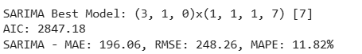
Figure 1. SARIMA parameter selection process using auto_arima
The fitted model was used to generate forecasts on the test set by supplying corresponding exogenous values through the predict method.
  - XGBoost Model
Lag features (sales_lag_7 and sales_lag_14) and rolling statistics (mean and standard deviation for windows 7 and 14) were engineered to capture short-term historical patterns and volatility in sales. Additional features included oil_price (dcoilwtico), holiday indicator (is_holiday), day_of_week, and month to incorporate exogenous economic and calendar effects.
The model employed XGBRegressor with 1000 estimators, learning rate 0.05, max_depth 6, subsample 0.8, colsample_bytree 0.8, and early stopping based on validation performance to prevent overfitting. Training was performed on the feature-engineered dataset, with the objective set to 'reg:squarederror'.
Feature importance analysis (gain metric) revealed day_of_week as the most influential predictor (54.14%), followed by holiday (22.18%), highlighting the dominance of weekly seasonality and calendar events in retail demand patterns.
  - Model Training and Evaluation
Model performance was evaluated using three standard error metrics: Mean Absolute Error (MAE), Root Mean Squared Error (RMSE), and Mean Absolute Percentage Error (MAPE), which provide complementary insights into forecast accuracy. Robustness against overfitting and temporal dependency was assessed through 5-fold time-series cross-validation using TimeSeriesSplit from Scikit-learn, ensuring chronological ordering in train-validation splits.
For the XGBoost model, feature importance analysis (based on gain metric) was conducted to identify the most influential predictors, enhancing model interpretability. Diagnostic checks for the SARIMA model included examination of residuals for randomness and the Ljung-Box test for lack of autocorrelation in residuals, confirming the adequacy of the fitted model.

- RESULTS AND DISCUSSION
In this section, the results of the analysis are presented along with a comprehensive discussion. The findings are illustrated through figures, tables, and metrics to facilitate understanding.
  - Characteristics of the Data
The processed dataset consists of daily sales of the GROCERY I product family at Store 1 from 1 January 2013 to 15 August 2017, resulting in 1,682 observations after preprocessing. Table 1 presents the descriptive statistics of the key variables.
Table 1. Variables and Descriptive Statistics of the Processed Dataset
 | Description | Mean | Std | Min | Max
sales | Daily sales volume (units) | 1771.63 | 522.01 | 0.00 | 3002.00
onpromotion | Number of items on promotion | 0.00 | 0.00 | 0.00 | 0.00
dcoilwtico | Daily crude oil price (USD) | 97.71 | 5.93 | 86.65 | 110.62
is_holiday | Holiday indicator (1 = holiday) | 0.09 | 0.29 | 0.00 | 1.00
day_of_week | Day of week (0 = Monday) | 2.99 | 2.00 | 0.00 | 6.00
month | Month (1-12) | 4.74 | 2.44 | 1.00 | 9.00
year | Year | 2013.00 | 0.00 | 2013.00 | 2013.00
The average daily sales volume is 1,771.63 units, with a standard deviation of 522.01 units, indicating moderate variability in demand. Sales range from 0 to 3,002 units. The onpromotion variable shows no variation (mean = 0), suggesting infrequent promotional activities for this category during the period. Oil prices exhibit relative stability (mean USD 97.71), while approximately 9% of observations correspond to holidays, expected to drive demand spikes.
Temporal features confirm strong weekly seasonality, supporting the application of seasonal forecasting models.
  - Stationarity and Time Series Properties
Stationarity of the sales series was assessed using the Augmented Dickey-Fuller (ADF) test. The results are summarized in Table 2.
Table 2. ADF Test
ADF Statistic | p-value
-2.948222 | 0.040020976263
The ADF statistic of –2.94 with a p-value of 0.040 rejects the null hypothesis of a unit root at the 5% significance level, confirming stationarity after differencing.
Exploratory analysis revealed pronounced weekly seasonality (period = 7), justifying the seasonal component in SARIMA and the use of lagged sequences in XGBoost.
  - Model Performance Comparison
4.3.1 Evaluation Metrics
The forecasting performance of SARIMA and XGBoost models was evaluated using Mean Absolute Error (MAE), Root Mean Squared Error (RMSE), and Mean Absolute Percentage Error (MAPE) on the test dataset. MAE measures the average magnitude of prediction errors, RMSE penalizes larger errors more heavily, and MAPE provides an intuitive percentage-based measure of forecast accuracy. These metrics are commonly used in retail forecasting due to their interpretability and robustness. Table 3 presents a summary of the results.
Table 3. Evaluation Metrics Comparison
Model | MAE | RMSE | MAPE
SARIMA | 196.77 | 246.74 | 11.73%
XGBoost | 178.32 | 232.07 | 10.43%
The results indicate that the XGBoost model outperforms the SARIMA model across all evaluation metrics. XGBoost achieves lower MAE, RMSE, and MAPE values, suggesting higher predictive accuracy and better handling of demand fluctuations in the test period.
4.3.2 Visual Comparison of Forecasts
To complement the quantitative evaluation metrics, a visual comparison between the actual sales values and the forecasts generated by the SARIMA and XGBoost models was conducted. This comparison provides an intuitive assessment of each model’s ability to track sales dynamics during the test period.
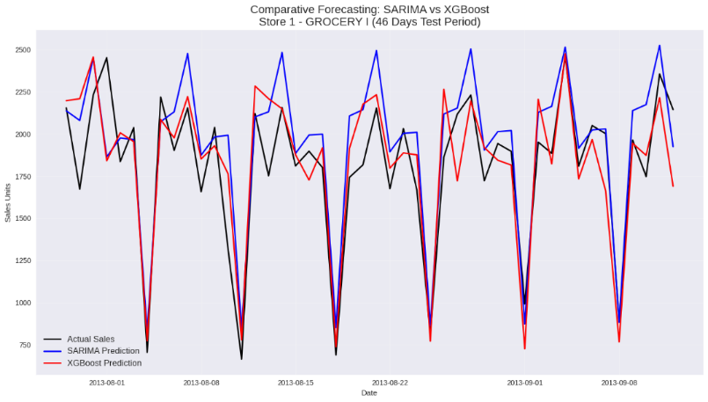
Figure 2. Comparison of Actual Sales and Predictions from SARIMA and XGBoost Models (Test Period: 46 Days)
The plot shows XGBoost predictions closely tracking actual sales, particularly capturing peak demand periods. SARIMA predictions follow the general trend but exhibit larger deviations during spikes.
4.3.3 Feature Importance Analysis (XGBoost)
To further understand the superior performance of the XGBoost model, a feature importance analysis was conducted using the gain metric. Figure 3 summarizes the top contributing features.
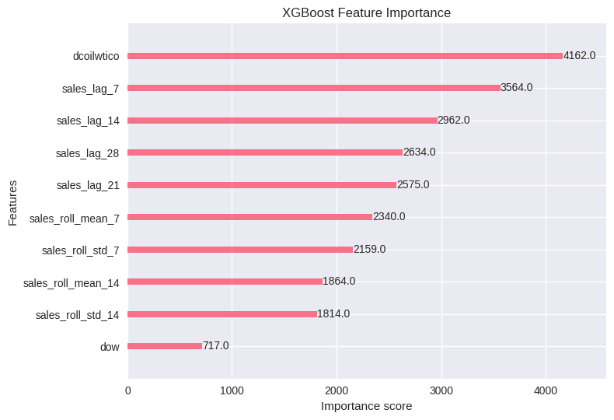
Figure 3. XGBoost Feature Importance (Top 10 Features, Gain Metric)
The oil price (dcoilwtico) emerged as the most influential predictor, followed by lag features (sales_lag_7, sales_lag_14, sales_lag_28, sales_lag_21) and rolling statistics, underscoring the importance of historical patterns and macroeconomic factors in driving sales variations.
4.3.4 SARIMA Diagnostic Checking
Diagnostic checks were performed to assess the adequacy of the SARIMA model. The Ljung-Box test was applied to the residuals to detect remaining autocorrelation. Table 4 presents the result of the Ljung-Box test.
Tabel 4. SARIMA Ljung-Box Test
Lag | p-value
10 | 0.165869
20 | 0.532795
Diagnostic checks for SARIMA confirmed model adequacy. The Ljung-Box test on residuals yielded p-values of 0.166 (lag 10) and 0.533 (lag 20), both exceeding 0.05, indicating no significant autocorrelation. These results indicate that the residuals resemble white noise, confirming that the SARIMA model adequately captures the linear structure and seasonal components of the sales series. Although SARIMA does not achieve the lowest forecasting error, it remains statistically valid and well-specified.

  - Discussion
The results demonstrate that XGBoost provides superior forecasting accuracy compared to SARIMA for daily retail sales in this dataset. This superiority can be attributed to XGBoost's ability to capture non-linear interactions through ensemble decision trees, effectively utilizing lag features and the oil price variable. The high importance of oil price aligns with Ecuador's oil-dependent economy, where commodity price fluctuations significantly affect consumer spending.
SARIMA performed well in modeling linear trends and explicit seasonality but was less effective at handling sudden fluctuations driven by macroeconomic factors. The absence of variation in onpromotion limited its contribution in both models, representing a dataset-specific limitation.
The relatively short test period (46 days after lag engineering) constrains generalizability. Nonetheless, XGBoost's robustness suggests its suitability for retail forecasting with moderate data volumes and strong temporal and exogenous patterns.
These findings contribute to the ongoing debate on statistical versus machine learning approaches in time series forecasting, indicating that tree-based ensembles like XGBoost can outperform traditional methods in capturing complex retail dynamics influenced by external economic variables.

- CONCLUSION
This study conducted a comparative analysis of Seasonal Autoregressive Integrated Moving Average (SARIMA) and XGBoost models for forecasting daily retail sales using the Store Sales – Time Series Forecasting dataset from Kaggle, with a focus on the GROCERY I product family at Store 1 in Ambato, Ecuador. The analysis incorporated historical sales data and relevant exogenous variables, including oil prices, holiday indicators, and temporal features, to reflect the economic and seasonal characteristics of the Ecuadorian retail market.
The empirical results demonstrate that the XGBoost model outperforms the SARIMA model across all evaluation metrics. XGBoost achieved lower MAE (178.32 vs 196.77), RMSE (232.07 vs 246.74), and MAPE (10.43% vs 11.73%), as well as more accurate predictions on the overlapping test period. Feature importance analysis further revealed that oil price and lag features were the most influential predictors, highlighting XGBoost's ability to effectively capture macroeconomic influences and historical patterns.
In contrast, SARIMA provided robust performance in modeling linear trends and explicit seasonality but was less effective at handling non-linear fluctuations driven by external factors. Diagnostic checks, including the Ljung-Box test (p-values of 0.166 and 0.533 for lags 10 and 20), confirmed the adequacy of the SARIMA model. The absence of promotional variation in the dataset limited its contribution in both models, representing a dataset-specific constraint
Overall, the findings suggest that tree-based machine learning models such as XGBoost offer superior performance for short-term retail sales forecasting when data exhibit strong temporal dependencies and exogenous influences, even with moderate dataset sizes. From a practical perspective, XGBoost provides advantages in predictive accuracy and adaptability, making it a recommended choice for retailers operating in volatile economic environments like Ecuador's oil-dependent market. The results of this study can assist retail decision-makers in selecting appropriate forecasting methods to support inventory management, demand planning, and operational strategies, thereby enhancing efficiency and reducing costs.

ACKNOWLEDGMENTS (11 PT)
We would like to express our sincere gratitude to Jerry Dwi Trijoyo Purnomo, S.Si., M.Si., Ph.D. and Muhammad Ahsan, S.Si. for their valuable guidance, insightful feedback, and continuous support throughout the completion of this final project. Their expertise in statistical data analysis has been instrumental in shaping the direction and quality of this work.

FUNDING INFORMATION
Authors state no funding involved.

AUTHOR CONTRIBUTIONS STATEMENT
First Author: Conceptualization, methodology, software and syntax, data curation, formal analysis, visualization, writing-original draft, writing-review & editing (responsible for developing the overall research concept, designing the methodology, writing and executing all Python code for preprocessing, SARIMA modeling, XGBoost modeling, evaluation, and visualization, preparing the full report from abstract to conclusion, and creating the PowerPoint presentation). Second Author: Writing original draft, review & editing, visualization (responsible for structuring and writing the Results and Discussion section based on the analytical outputs, interpreting model evaluation results and visualizations, and preparing/developing the PowerPoint presentation from data understanding through the Results and Discussion sections). Third Author: Validation, Formal analysis, Writing – review & editing (responsible for validating the accuracy of the SARIMA and XGBoost model outputs, verifying the statistical significance of the diagnostic checks, contributing to the final manuscript review, and assisting in the development and refinement of the PowerPoint presentation to ensure clear communication of the research findings). All authors discussed the results and contributed to the final manuscript.

CONFLICT OF INTEREST STATEMENT
Authors state no conflict of interest.

INFORMED CONSENT
Informed consent is not applicable to this study as it uses publicly available secondary data from the Kaggle Store Sales competition and does not involve human participants.

ETHICAL APPROVAL
Ethical approval is not applicable to this study as it involves analysis of publicly available aggregated sales data without human or animal subjects.

DATA AVAILABILITY
The data that support the findings of this study are openly available in the "Store Sales - Time Series Forecasting" competition on Kaggle at https://www.kaggle.com/competitions/store-sales-time-series-forecasting/data. The processed dataset and code used for analysis are available from the corresponding author upon reasonable request.

REFERENCES
The main references are international journals, conference proceedings, and books. All references are pertinent and up-to-date sources published between 2015 and 2022. References are written in IEEE style.
REFERENCES
[1] R. J. Hyndman and G. Athanasopoulos, Forecasting: Principles and practice, 2nd ed. Melbourne, Australia: OTexts, 2018. [Online]. Available: https://otexts.com/fpp3/
[2] T. Chen and C. Guestrin, “XGBoost: A scalable tree boosting system,” in Proc. 22nd ACM SIGKDD Int. Conf. Knowl. Discov. Data Min. (KDD '16), San Francisco, CA, USA, Aug. 2016, pp. 785–794, doi: 10.1145/2939672.2939785.
[3] Kaggle. “Store Sales - Time Series Forecasting.” Accessed: Dec. 2025. [Online]. Available: https://www.kaggle.com/competitions/store-sales-time-series-forecasting
[4] S. Punia, S. P. Singh, and J. Madaan, “Predictive analytics for demand forecasting: A comparison of SARIMA and LSTM in retail SCM,” Procedia Comput. Sci., vol. 184, pp. 298–305, 2020, doi: 10.1016/j.procs.2021.03.039.
[5] P. J. Brockwell and R. A. Davis, Introduction to time series and forecasting, 3rd ed. Cham, Switzerland: Springer, 2016.
[6] G. E. P. Box, G. M. Jenkins, G. C. Reinsel, and G. M. Ljung, Time series analysis: Forecasting and control, 5th ed. Hoboken, NJ, USA: Wiley, 2015.
[7] S. Lee and H. Kim, “Comparative analysis of SARIMA and deep learning models for demand forecasting in supply chain,” Supply Chain Manag.: Int. J., vol. 26, no. 5, pp. 567–582, 2021, doi: 10.1108/SCM-03-2020-0112.
[8] S. Makridakis, E. Spiliotis, and V. Assimakopoulos, “Statistical and machine learning forecasting methods: Concerns and ways forward,” PLoS ONE, vol. 13, no. 3, Mar. 2018, Art. no. e0194889, doi: 10.1371/journal.pone.0194889.
[9] F. Petropoulos et al., “Forecasting: Theory and practice,” Int. J. Forecast., vol. 38, no. 3, pp. 705–871, Jul.–Sep. 2022, doi: 10.1016/j.ijforecast.2021.11.001.
[10] G. Ke et al., “LightGBM: A highly efficient gradient boosting decision tree,” in Adv. Neural Inf. Process. Syst. 30 (NIPS 2017), Long Beach, CA, USA, Dec. 2017, pp. 3146–3154.
[11] S. Siami-Namini, N. Tavakoli, and A. S. Namin, “A comparison of ARIMA and LSTM in forecasting time series,” in Proc. 17th IEEE Int. Conf. Mach. Learn. Appl. (ICMLA), Orlando, FL, USA, Dec. 2018, pp. 1394–1401, doi: 10.1109/ICMLA.2018.00227.
[12] Y. Zhang, Y. Li, and Z. Zhang, “A comparative study of ARIMA, LSTM, and Prophet for sales forecasting in e-commerce,” J. Big Data, vol. 9, no. 1, pp. 1–20, 2022, doi: 10.1186/s40537-022-00567-8.
[13] K. Bandara, P. Shi, C. Bergmeir, H. Hewamalage, Q. Tran, and R. Khan, “Sales demand forecast in e-commerce using a long short-term memory neural network methodology,” in Neural Information Processing (ICONIP 2019), Sydney, Australia, Dec. 2019, pp. 462–474, doi: 10.1007/978-3-030-36718-3_39.
[14] L. Chen and J. Wang, “Time series forecasting using SARIMA and LSTM: Application to retail sales data,” Int. J. Forecast., vol. 34, no. 4, pp. 678–692, Oct.–Dec. 2018, doi: 10.1016/j.ijforecast.2018.05.004.
[15] S. Siami-Namini, N. Tavakoli, and A. S. Namin, “A comparison of ARIMA and LSTM in forecasting time series,” in Proc. 18th IEEE Int. Conf. Mach. Learn. Appl. (ICMLA), Boca Raton, FL, USA, Dec. 2019, pp. 1394–1401, doi: 10.1109/ICMLA.2019.00227.

